**Name: Debjyoti Sarkar Sumonta**

**Student ID: 22341019**

**CSE321 Section 5**

**Task 1**

#include <pthread.h>

#include <stdio.h>

#include <stdlib.h>

#include <string.h>

#include <unistd.h>

#define MAX 10

#define BUFLEN 6

#define NUMTHREAD 2

void *consumer(void *id);

void *producer(void *id);

char buffer[BUFLEN + 1];

char source[BUFLEN + 1];

int pCount = 0;

int cCount = 0;

int buflen;

// Initialize mutex and condition variables

pthread_mutex_t count_mutex = PTHREAD_MUTEX_INITIALIZER;

pthread_cond_t empty = PTHREAD_COND_INITIALIZER;

pthread_cond_t full = PTHREAD_COND_INITIALIZER;

int thread_id[NUMTHREAD] = {0, 1};

int src_index = 0;

int count = 0; // for accessing values

int main() {

pthread_t thread[NUMTHREAD];

strcpy(source, "abcdef");

buflen = strlen(source);

for (int i = 0; i < NUMTHREAD; i++) {

int *a = malloc(sizeof(int));

*a = thread_id[i];

if (i == 0) {

pthread_create(&thread[i], NULL, &producer, a);

} else {

pthread_create(&thread[i], NULL, &consumer, a);

}

}

for (int i = 0; i < NUMTHREAD; i++) {

pthread_join(thread[i], NULL);

}

}

// Producer

void *producer(void *id) {

int thread_id = *(int *)id;

for (int i = 0; i < MAX; i++) {

pthread_mutex_lock(&count_mutex);

while (count >= BUFLEN) {

pthread_cond_wait(&full, &count_mutex);

}

char x = source[src_index % BUFLEN];

buffer[count] = x;

src_index++;

count++;

pCount++;

printf("%d produced %c by Thread %d\n", i, x, thread_id);

pthread_cond_signal(&empty);

pthread_mutex_unlock(&count_mutex);

}

pthread_exit(NULL);

}

// Consumer

void *consumer(void *id) {

int thread_id = *(int *)id;

for (int i = 0; i < MAX; i++) {

pthread_mutex_lock(&count_mutex);

while (count <= 0) {

pthread_cond_wait(&empty, &count_mutex);

}

char y = buffer[count - 1];

count--;

cCount++;

printf("%d consumed %c by Thread %d\n", i, y, thread_id);

pthread_cond_signal(&full);

pthread_mutex_unlock(&count_mutex);

}

pthread_exit(NULL);

}

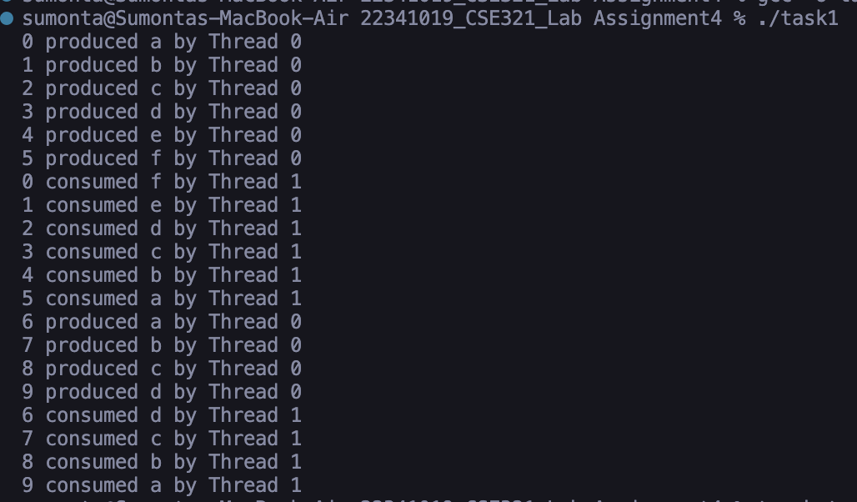

**Task 2**

#include <pthread.h>

#include <semaphore.h>

#include <stdio.h>

#include <stdlib.h>

#define MaxCrops 5

#define warehouseSize 5

sem_t empty;

sem_t full;

int c_index = 0;

int w_index = 0;

char crops[warehouseSize] = {'R', 'W', 'P', 'S', 'M'};

char warehouse[warehouseSize] = {'N', 'N', 'N', 'N', 'N'};

pthread_mutex_t mutex;

void *Farmer(void *arg) {

int thread_id = *(int *)arg;

for (int i = 0; i < MaxCrops; i++) {

sem_wait(&empty);

pthread_mutex_lock(&mutex);

char x = crops[c_index % warehouseSize];

warehouse[w_index % warehouseSize] = x;

printf("Farmer %d: Insert crops %c at %d\n", thread_id, x, w_index);

c_index = (c_index + 1) % warehouseSize;

w_index = (w_index + 1) % warehouseSize;

pthread_mutex_unlock(&mutex);

sem_post(&full);

}

free(arg);

pthread_exit(NULL);

}

void *ShopOwner(void *arg) {

int thread_id = *(int *)arg;

for (int i = 0; i < MaxCrops; i++) {

sem_wait(&full);

pthread_mutex_lock(&mutex);

char y = warehouse[(w_index - 1) % warehouseSize];

warehouse[(w_index - 1) % warehouseSize] = 'N';

printf("Shop owner %d: Remove crops %c from %d\n", thread_id, y, (w_index - 1) % warehouseSize);

w_index = (w_index - 1) % warehouseSize;

pthread_mutex_unlock(&mutex);

sem_post(&empty);

}

printf("ShopOwner %d: ", thread_id);

for (int i = 0; i < warehouseSize; i++) {

printf("%c ", warehouse[i]);

}

printf("\n");

free(arg);

pthread_exit(NULL);

}

int main() {

// Initialize thread, mutex, and semaphores

pthread_t Far[5], Sho[5];

pthread_mutex_init(&mutex, NULL);

sem_init(&empty, 0, warehouseSize);

sem_init(&full, 0, 0);

int a[5] = {1, 2, 3, 4, 5};

for (int i = 0; i < 5; i++) {

int *p = malloc(sizeof(int));

int *q = malloc(sizeof(int));

*p = a[i];

*q = a[i];

pthread_create(&Far[i], NULL, &Farmer, p);

pthread_create(&Sho[i], NULL, &ShopOwner, q);

}

for (int i = 0; i < 5; i++) {

pthread_join(Far[i], NULL);

pthread_join(Sho[i], NULL);

}

pthread_mutex_destroy(&mutex);

sem_destroy(&empty);

sem_destroy(&full);

return 0;

}

